-
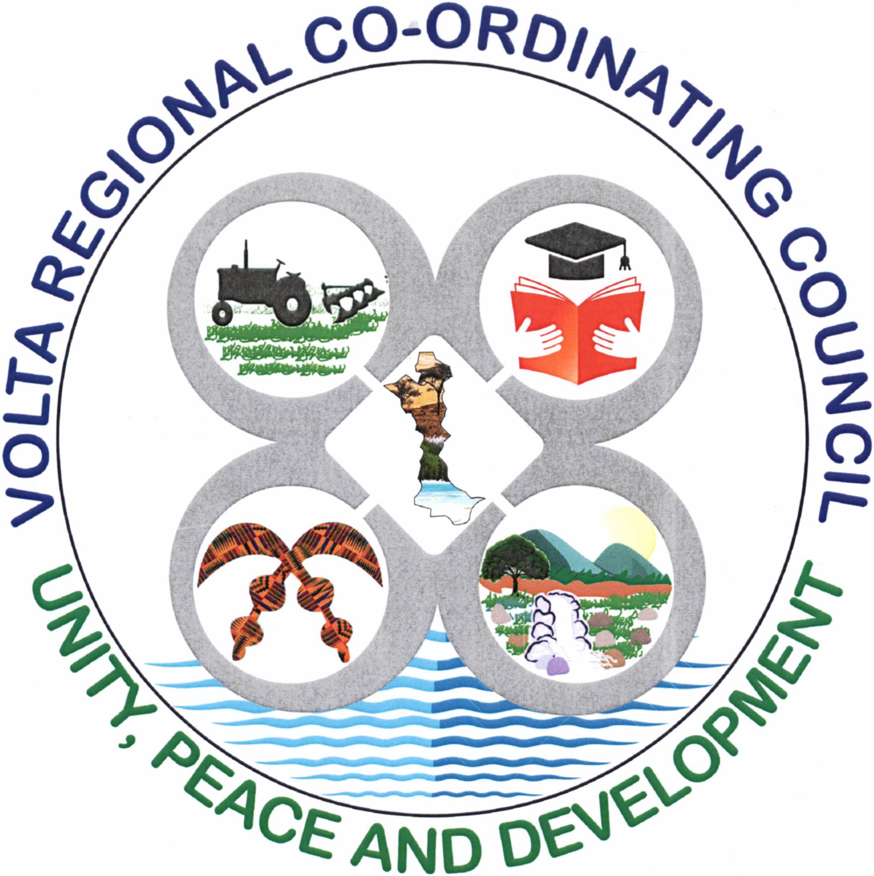
VOLTA REGIONAL CO-ORDINATING COUNCIL
(VRCC)

2025

Document Number: VRCC/RTI/2025 Subject to Revision by your institution
Government of Ghana

Right to Information Manual

Table of Contents
Table of Contents………………………………………………………………………………….........ii
1. Overview 1
2. Directorates and Departments under Volta Regional Coordinating Council (VRCC) 2
2.1 Description of Activities of each Directorate and Department 3
2.2 Volta Regional Coordinating Council’s Organogram 1
2.3 Agencies Under the VRCC 1
2.4 Classes and Types of information 5
3. Processing and Decision on Application – S. 23 6
4. Amendment of Personal Record 7
4.1 How to apply for an Amendment 7
5. Fees and Charges for Access to Information 8
6. Appendix A: Standard RTI Request Form 9
7. Appendix B: Contact Details of Volta Regional Coordinating Council’s Information Unit 13
8. Appendix C: Acronyms 14
9. Appendix D: Glossary 15

Overview
This Right to Information (RTI) Manual is pursuant to the provisions of the recently passed Act, (Act 989) by Parliament and assented to by the President, Nana Addo Dankwa Akuffo-Addo. The Act gives substance to the constitutional right to information provided under Article 21 (1) (f) of the Constitution, enabling citizens access to official information held by government institutions, and the qualifications and conditions under which the access may be obtained. In accordance with Section 80, the Act applies to information which came into existence before, or which will come into existence after the commencement of the Act.

1.1 Purpose of Manual – To inform/assist the public on the organizational structure, responsibilities and activities of the Volta Regional Co-ordinating Council (VRCC) and provide the types of information and classes of information available at VRCC including the location and contact details of its information officers and units.

Directorates and Departments under Volta Regional Coordinating Council (VRCC)
This section describes the institution’s vision and mission and lists the names of all Directorates and Departments under the institution, including the description of organizational structure, responsibilities, details of activities and classes and types of information accessible at a fee.

VISION
The Volta Regional Coordinating Council seeks to attain a peaceful, stable united, progressive and prosperous region with a high standard of living for its people.

MISSION
The Volta Regional Coordinating Council exists to facilitate the overall development of the Volta Region through efficiently harmonizing, coordinating, monitoring, and evaluating all plans and programmes of Ministries, Departments and Agencies (MDAs), Municipal / District Assemblies (M/DAs) and Civil Society Organizations (CSOs) in the Region within the context of excellence, transparency and accountable governance.
Directorates and Departments under Volta Regional Coordinating Council (VRCC)
- Finance Unit
- Administration
- Regional Economic Planning Unit
- Regional Budget Division
- Public Relations Unit
- Human Resource Management
- Client Service Unit
- Internal Audit Unit
- Management Information System Unit
- Procurement Unit
- Housing Department
- Environmental Health & Sanitation Unit
- Department of Feeder Roads
- Department of Agriculture
- Records Management Unit
- Department of Parks and Gardens
- Department of Social Welfare
- Department of Community Development
- Public Works Department
Responsibilities of the Institution:
Monitoring and evaluating, Coordinating and ensuring security, orderliness and peace in the Region.
Coordinating and harmonizing the effective administration of all the 18 Municipal and Districts within the Volta Region

Ensuring the smooth operation of the entire Government Machinery in the region and its efficient and effective service delivery to maximize good governance and public welfare.

Formulating comprehensive development framework for the region to guide the efforts of MMDA’s, other agencies, NGO’s and all other development partners
Ensuring the equitable allocation of resources including funds for the smooth administration of the Region and the prudent utilization of resources allocated.

2.1 Description of Activities of each Directorate and Department

Directorate/Department | Responsibilities/Activities
Finance and Administration | Facilitates the smooth operation of other core functions within the institution through the provision of administrative, and accounting support system
Regional Planning Coordinating Unit (RPCU) | Responsible for the planning, organizing, leading, Controlling and monitoring of activities of Municipal and District Assemblies in the region.
Regional Budget Division | Responsible for coordinating the processes for the preparation of the regional mid-term and annual budget, related government policies and monitoring of MMDAs in the region. Also responsible for the provision of guidelines to the RPCU on budgeting policies and issues as well as revenue mobilization.
Public Relations Unit | The Unit exists to: Develop, implement and review communication strategies for VRCC. It also ensures that the details of the VRCC’s activities are communicated appropriately to all relevant offices and the public. It also serves as the mouthpiece of the Council.
Human Resource Management Unit | The department is responsible for posting and training staff, maintaining inter-office relationships and interpreting employment laws. Other roles include performance management and assessment.
Client Service Unit | The Client Service Unit is set up to receive complaints and address them and provides information on the nature of the operations of the Council.
Procurement Unit | The Procurement Unit is the office responsible for the acquisition of supplies, services and construction in support of the Council’s business. The Procurement Unit issues purchase orders, develops terms of contracts and ensures all procurement activities are following the regulations governing procurement activities.
Internal Audit Unit | - Ensures compliance with established internal control procedures by examining records, reports, operating practices and documentation.  - Verifies assets and liabilities by comparing items to documentation.
Management Information Unit (I.T.) | - The Information Communication Technology Unit is responsible for all computing needs of the institution. It provides services such as repair and replacement of devices, updating operating systems and providing general servicing and maintenance of computer device and data recovering.
Environmental Health & Sanitation Unit | - Responsible for the supervision of control of environmental pollution, management of solid and liquid waste, food hygiene, sanitation at marketplaces and at the premises of the council, lorry terminals and mobilization of communities for communal labor activities. They are also responsible for the control of stray animals, slaughterhouse inspection and supervise the burial of infectious bodies.
Department of Agriculture | The agency is responsible for the promotion of agricultural development by providing the policy framework, public investments and support services needed for domestic and export-oriented business enterprises
Records Management Unit | The Unit is responsible for managing all records of VRCC including incoming and outgoing letters and other communique.
Feeder Roads | Feeder roads are crucial for connecting rural communities to main roads, facilitating the movement of people, farm produce, and goods to markets, thereby boosting local economies and reducing poverty; their responsibilities include construction, maintenance (like grading and patching), and development of supporting infrastructure (culverts, bridges) to ensure all-weather accessibility for socio-economic growth, often using labor-intensive methods
Parks and Gardens | The Department of Parks and Gardens is responsible for planning, developing, and maintaining urban green spaces to promote environmental, aesthetic, and recreational benefits. Their key responsibilities focus on enhancing the quality of life, fostering biodiversity, and providing safe public, recreational, and educational spaces.
Public Works Department | Responsible for supervising the construction and maintenance of all Government bungalows, office blocks and other landed properties
Records Management Unit | The Unit is responsible for managing all records of VRCC including incoming and outgoing letters and other communique
Stores | Storekeeper manages inventory, ensuring accurate tracking, organization, handling stock records, audits, and maintaining a clean, safe environment while coordinating with procurement and other teams to prevent shortages and overstocking.

2.2 Volta Regional Coordinating Council’s Organogram

2.3 AGENCIES UNDER VOLTA REGIONAL COORDINATING COUNCIL (VRCC)
Agencies under Volta Regional Coordinating Council (VRCC)
1. Ho Municipal Assembly
2. Hohoe Municipal Assembly
3. Ketu South Municipal Assembly
4. Ketu North Municipal Assembly
5. Ketu South Municipal Assembly
6. Keta Municipal Assembly
7. Akatsi South Municipal Assembly
8. South Tongu District Assembly
9. Central Tongu District Assembly
10. North Tongu District Assembly
11. Akatsi North District Assembly
12. Agotime Ziope District Assembly
13. Adaklu District Assembly
14. Ho West District Assembly
15. South Dayi District Assembly
16. North Dayi District Assembly
17. Anloga District Assembly
18. Afadzato South District Assembly

MUNICIPAL ASSEMBLIES
Responsibilities of the Agency:  - To exercise political & administrative authority in the area  - To promote local economic development  - Provide guidance, give directive to supervise other administrative authorities in the municipal as may be prescribed by law  - Responsible for the overall development of the municipality  - To formulate and execute plans, programmes and strategies to effectively mobilize the resources necessary for the overall development of the municipal area.  - Responsible for maintenance of security and public safety in co-operation with the appropriate national security and law enforcement agencies.  - To initiate programs for the development of basic infrastructure and provide municipal works and services in the municipal area. | Details of Activities:  - To execute approved development plans for the area.  - To ensure and monitor proper revenue mobilization for developmental projects in the municipal area.  - To initiate and encourage joint participation with other people or bodies to execute approved development plans.  - To monitor the execution of projects under approved development plans and assess and evaluate their impact on the national economy in accordance with government policies.  - Be subject to the general guidance and direction of the president on matters of national policy  - Act in co-operation with the appropriate public co-operations, statutory bodies and non-governmental organizations in the discharge of their duties within the municipality.

DISTRICT ASSEMBLIES
Responsibilities of the Agency:  - Exercise political and administrative authority the district.  - Promote the local economic development of the district  - Provide guidance, give directions and supervise other administrative authorities in the district too as may be prescribed by law.  - Formulate and execute plans, programs and strategies for the effective mobilization of the resources necessary for the overall development of the district.  - Ensure ready access to courts in the district for the promotion of justice.  - Act to preserve and promote the cultural heritage within the district.  - Perform any other functions that may be provided under the Local Governance Act, Act 936, 2016. | Details of Activities:  - To execute approved development plans for the area.  - To ensure and monitor proper revenue mobilization for developmental projects in the municipal area.  - To initiate and encourage joint participation with other people or bodies to execute approved development plans.  - To monitor the execution of projects under approved development plans and assess and evaluate their impact on the national economy in accordance with government policies.  - Be subject to the general guidance and direction of the president on matters of national policy.  - Act in co-operation with the appropriate public co-operations, statutory bodies and non-governmental organizations in the discharge of their duties within the district.

2.4 Classes and Types of Information

List of various classes of information in the custody of the institution:
- Monitoring Reports
- Quarterly and Annual Reports
- Procurement Records
- Security
- Medium Development Plans
- Annual Action & Procurement Plans and Composite Budget

Types of Information Accessible at a fee:
- Monitoring Reports
- Quarterly and Annual Reports
- Procurement Records
- Medium Development Plans
- Annual Action & Procurement Plans and Composite Budget

EXEMPT
- Security

Processing and Decision on Application – S. 23

1
2
3
Application made under s.18 is submitted to the Information Unit/ Registry of the Public Institution
The designated RTI Officer shall upon receipt of the application make a determination as to whether or not the application is one that safeguards the life or liberty of a person within the ambit of s. 23 (7)
4
5
6
Where the application does not fall within the ambit of s. 23 (7), the RTI Officer shall within 14 days of receiving the request, engage the relevant persons within the institution and the information generating directorate to confirm the availability of the information requested
Where an EXTENSION of time is needed, RTIO shall comply with S. 25.
IF NOT
Notice of the Decision shall be communicated to the Applicant by or on the 14th working day from when the application was made.
The Decision shall where it confirms the availability of information state the manner in which access will be granted and whether or not access to the information shall be given in part and the reasons for giving only part. (s. 23(1)(2)(3).
Where the information requested shall be refused, the RTIO shall notify the applicant within 12 days of receiving the application, communicating the refusal of the application and the reason for the refusal. Where it falls within the exempt category s.5-17; s.23 (10);s.24; the RTIO shall state the section/reason the refusal was based.

Amendment of Personal Record
A person given access to information contained in records of a public institution may apply for an amendment of the information if the information represents the personal records of that person and in the person’s opinion, the information is incorrect, misleading, incomplete or out of date.

4.1 How to apply for an Amendment
- The application should be in writing indicating.
- Name and proof of identity.
- Particulars that will enable the records of the public institution identify the applicant
- The incorrect, misleading, incomplete or the out of date information in the record.
- Signature of the applicant
- For incomplete information claimed or out of date records, the application should be accompanied with the relevant information which the applicant considers necessary to complete the records.

- The address to which a notice shall be sent should be indicated.

- The application can then be submitted at the office of the public institution

Fees and Charges for Access to Information

The Act mandates Parliament in Section 75 to approve a fee that public institutions can charge. However, fees shall apply to only the three circumstances stated below:
- Request for information in a language other than the language in which the information is held. (s.75) (3).

- When request is made for a written transcript of the information, a reasonable transcription cost may be requested by the Information Officer. (s.75) (4).

- Cost of media conversion or reformatting. (s.75) (5).
Under Section 75 (2), fees are not payable for:
- reproduction of personal information
- information in the public interest
- information that should be provided within stipulated time under the Act
- an applicant who is poor or has a disability
- time spent by the information officer in reviewing the information
- time spent by the information officer to examine and ensure the information is not exempt
- preparing the information

Section 76 subjects the retention of charges received by a public institution to the Constitution. Thus a public institution is authorized to retain charges received under the Act to be used only to defray expenses incurred by the public institution in the performance of functions under the Act and be paid into a bank account opened for the purpose with the approval of the Controller and Accountant-General.

Appendix A: Standard RTI Request Form
[Reference No.: ………………………….]

APPLICATION FOR ACCESS TO INFORMATION UNDER THE RIGHT TO INFORMATION ACT, 2019 (ACT 989)

 | Name of Applicant:
2. | Date:
3. | Public Institution:
4. | Date of Birth: |  | DD |  |  | MM |  | YYYY
5. | Type of Applicant: |  | Individual Organization/Institution
6. | TIN Number
7. | If Represented, Name of Representative:
7 (a). | Capacity of Representative:
8. | Type of Identification: National ID Card Passport Voter’s ID  Driver’s License
8 (a). | Id. No.:
9. | Description of the Information being sought (specify the type and class of information including cover dates. Kindly fill multiple applications for multiple requests):
10. | Manner of Access: |  |  | Inspection of Information  Copy of Information  Viewing / Listen  Written Transcript  Translated (specify language)
10 (a). | Form of Access: |  |  | Hard copy Electronic copy Braille
11. | Contact Details: |  |  | Email Address__________________________________  Postal Address_________________________________  Tel: _________________________________________
12. | Applicant’s signature/thumbprint:
13. | Signature of Witness (where applicable)  “This request was read to the applicant in the language the applicant understands and the applicant appeared to have understood the content of the request.”

Appendix B: Contact Details of VRCC’s Information Unit

Name of Information/Designated Officer:
AMENYO FOSTER/ JOSEPHINE DAKE-ABRAHAMS

Telephone/Mobile number of Information Unit:
/ 0249676659/ 0202556266
Email:
Postal Address of the institution:
P.O. BOX 119, Ho

Appendix C: Acronyms
Instructions: Provide a list of acronyms and associated literal translations used within the manual. List the acronyms in alphabetical order using the table below.
Table 1 Acronyms
Acronym | Literal Translation
CSO’s | Civil Society Organizations
CWSA | Community Water and Sanitation Agency
EPA | Environmental Protection Agency
GNA | Ghana News Agency
I.T | Information Technology
MDA’s | Ministries, Departments and Agencies
M/DAs | Municipal / District Assemblies
MMDAs | Metropolitan, Municipal and District Assemblies
NGO’s | Non-Governmental Agencies
NDPC | National Development Planning Commission
VRCC | Volta Regional Coordinating Council
RTI | Right To Information
RPCU | Regional Planning Coordinating Unit
s | Section
YEA | Youth Employment Agency
NDPC | National Development Planning Commission
YEA | Youth Employment Agency

Appendix D: Glossary
This Glossary presents clear and concise definitions for terms used in this manual that may be unfamiliar to readers listed in alphabetical order. Definitions for terms are based on section 84 of the RTI Act.

Table 2 Glossary
Term | Definition
Access | Right to Information
Access to information | Right to obtain information from public institutions
Contact details | Information by which an applicant and an information officer may be contacted
Court | A court of competent jurisdiction
Designated officer | An officer designated for the purposes of the Act who perform similar role as the information officer
Exempt information | Information which falls within any of the exemptions specified in sections 5 to 16 of the Act
Function | Powers and duties
Government | Any authority by which the executive authority of the Republic of Ghana is duly exercised
Information | Information according to the Act includes recorded matter or material regardless of form or medium in the possession or under the control or custody of a public institution whether or not it was created by the public institution, and in the case of a private body, relates to the performance of a public function.
Information officer | The information officer of a public institution or the officer designated to whom an application is made
Public | Used throughout this document to refer to a person who requires and/or has acquired access to information.
Public institution | Includes a private institution or organization that receives public resources or provides a public function
Right to information | The right assigned to access information
Section | Different parts of the RTI Act

